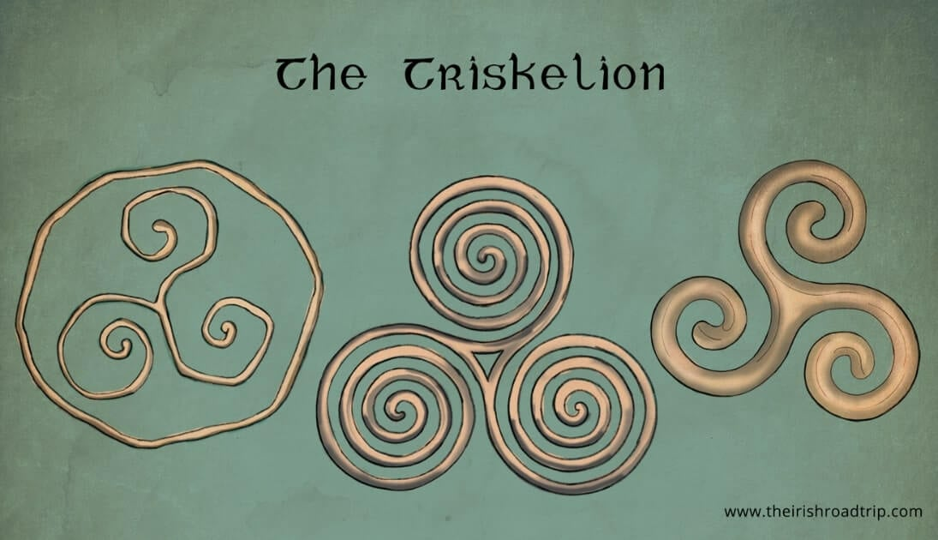

The Triskele

The triskele, or triskelion, is an ancient symbol of triplicity, representing cycles, motion, and interconnectedness, often depicted as three spirals or three legs radiating from a central point.

Origins and History
The triskele dates back to the Neolithic era, appearing on artifacts such as the Newgrange in Ireland around 3200 BCE, making it one of the oldest known symbols in human history. Itsname derives from the Greek word triskeles, meaning "three legs," though the symbol itself predates Greek usage. Variations include triple spirals and three bent human legs, which have appeared in European Neolithic, Bronze Age, and Celtic art, as well as in Greek antiquity and Hellenistic coinage.

Symbolism
The triskele embodies the concept of triplicity, a central theme in Celtic and pre-Celtic cultures. Common interpretations include:

- Life, death, and rebirth
- Past, present, and future
- Earth, water, and sky
- Spiritual, physical, and celestial realms
The spirals suggest continuous motion and cycles, reflecting the natural flow of time and the interconnectedness of all things. In Celtic mythology, it has also been associated with the Triple Goddess—maiden, mother, and crone—symbolizing feminine aspects of life and the cycles of nature.

Cultural and Modern Usage
The triskele has been widely adopted across cultures and eras:
- Celtic art and jewelry: Represents spiritual growth and personal development
Flags and heraldry: Featured on the Isle of Man, Sicily, and Brittany
Modern emblems: Incorporated in the Irish Air Corps and the U.S. Department of Transportation logo
- Popular culture: Used in tattoos, decorative art, and media, often retaining its symbolic meanings of motion, cycles, and balance Interpretation

The triskele’s meaning can vary depending on context, but it consistently emphasizes triplicity, continuity, and progression. It may symbolize personal growth, spiritual enlightenment, or the eternal flow of life, and its threefold design encourages reflection on the interconnectedness of different aspects of existence.

In summary, the triskele is a timeless symbol of threefold unity and perpetual motion, bridging ancient traditions with modern cultural and spiritual interpretations.

